**DATA 201 – Assignment 2**

Alex Stevenson – 30073617

**Survey Goal:**

The goal of this survey is to quantify and compare the mental health of university and college students. The survey will consider their relation between school and other factors of their life, such as sleep, mental and physical health, and workload.

**Target Participants:**

University and College students

**Recruitment Message:**

We are requesting your help with a study at the University of Calgary on the mental health of average university and college students. The goal of the study is to draw comparisons and relate the mental health of current university and college students to various factors of their lives. You will be asked a handful of questions about your current place in university and about various aspects of your life that are related to your mental health. You must be currently enrolled in a university or college to be eligible to participate. The study contains ten simple questions and will take approximately ten minutes to complete.

The study is fully anonymous. Your data will be kept confidential and only the aggregated results of all participants will be published.

With respect to your time spent to complete our survey, participants will be entered into a random draw of several gift certificates to Amazon.com, with rewards of up to $50.

**Question 1:**

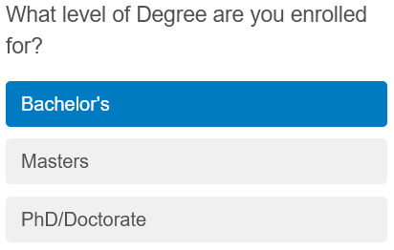

The survey starts by asking the participant for the level of degree they are enrolled for. This will provide valuable data and let us easily categorize the results, to see if there are any discrepancies between the different levels.

It also allows the results to represent a certain amount of university experience, where a majority of participants receiving Bachelor’s degrees have likely only been enrolled in University for 0 to 5 years.

It is possible and likely that the level of degree is related to certain mental health factors that University students could be facing.

**Level of Measurement:** Ordinal

This survey question provides Ordinal data, as the three results here are categorical, but with meaningful order.

**Question 2:**

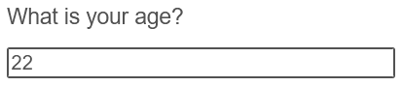

The next question is a simple one to get the participants age. This provides extremely helpful data as it allows the results to consider the relative maturity and life-experience between different participants. Younger participants are likely at greater risk for mental health issues, due to a lack of experience outside of high school and being new to the university experience.

This question, paired with the first question, get a general feel of where participants are in their lives and let us treat the resulting data accordingly.

**Level of Measurement:** Ratio

This survey question provides Ratio data, as there is a numerical degree of difference with a non-arbitrary origin.

**Question 3:**



The third question is regarding the participants major. This should allow for interesting conclusions to be drawn from the dataset, if certain majors have a higher rate of mental health issues. It also allows us to remove bias in the full data set by accounting for the relative amount of responses by different faculties. Consider a situation with an overwhelming amount of survey responses by participants that are in a major with exceedingly low mental health issues.

**Level of Measurement:** Nominal

This is just a list of categorical data, with no way to compare them directly.

**Question 4:**

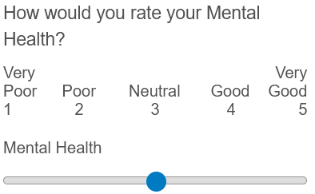

Now that we have a general idea of the participant, we can ask them for a direct rating of their mental health. This gives us a general baseline of what the participant thinks their mental health is at before being able to relate it with future survey questions.

**Level of Measurement:** Interval

There are degrees of difference here that are obvious between 1 and 5, but there is an arbitrary origin.

**Question 5:**

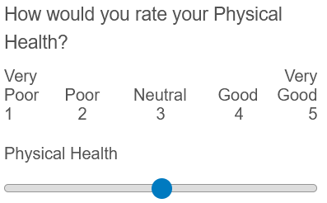

Physical health is a major factor of mental health. Now that we have a baseline of how the participant feels about their mental health, we can compare it to their physical health to begin to draw conclusions. Later survey questions can also be related to this, perhaps a participant is in poor physical health due to having too high of a school workload and not enough time to exercise, both of which are affecting their mental health in a negative way.

**Level of Measurement:** Interval

Similarly to question 4, there are degrees of difference between the answers with an arbitrary origin.

**Question 6:**

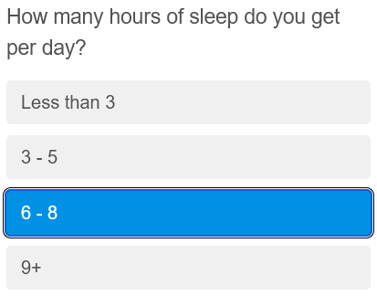

Studies have shown that the amount of sleep somebody gets is directly related to both their mental and physical health, relating to the previous two questions. We can use the result of this along with the participants own rating on their mental and physical health to see how their sleep schedule may be affecting them.

**Level of Measurement:** Ratio

A series of values of hours of sleep, they are directly comparable with clear degrees of difference (6 hours of sleep is twice as many as 3 hours of sleep) along with a non-arbitrary origin of 0.

**Question 7:**

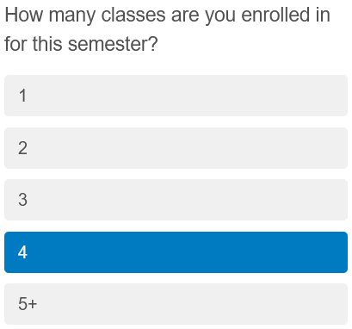

Now that we know hours of sleep along with the participants view of their mental and physical health, we can consider the number of classes they are enrolled in. This, paired with the major and degree type of the participant, can be used to determine the quantity of schoolwork expected for students with similar circumstances. There should be a correlation between number of courses, hours of sleep, and mental health of participants.

**Level of Measurement:** Ratio

Again these values are directly comparable with a non-arbitrary origin.

**Question 8:**

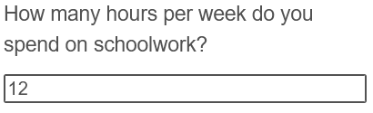

Now that we know how many classes the participant is enrolled in, we can determine the number of hours they actually spend on schoolwork every week. The results of this question, added to the hours of sleep the participant gets, can determine a rough estimate of how much free time the participant has. Free time is likely to correlate with physical and mental health.

**Level of Measurement:** Ratio

This is a numeric value where the origin of 0 means that there are no hours being spent on schoolwork.

**Question 9:**

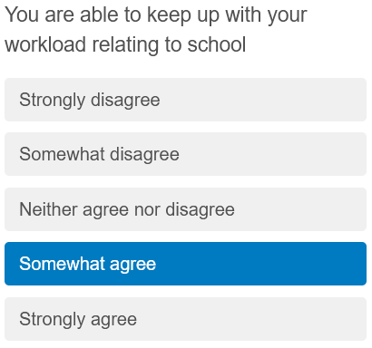

Now that we have a feel for the participant’s ability to keep on top of their schoolwork with their hours of work and hours of sleep, we ask them directly if they feel they are able to keep up with it. If they have a lot of schoolwork, don’t get much sleep, and are unable to keep up with their school workload, there should be correlation with their mental and physical health. However there should be a higher mental health estimate if they are able to keep up with a high school workload.

**Level of Measurement:** Ordinal

This is a collection of categorical data; however the data is ordered and comparable with itself.

**Question 10:**

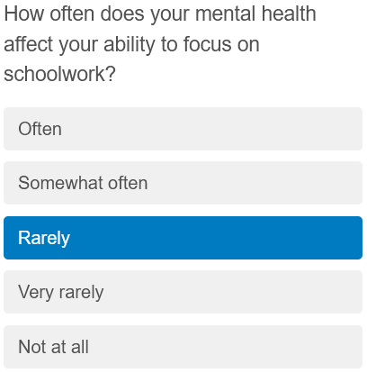

The final question of the survey simply asks the participant directly if they feel as though their mental health actively affects their schoolwork. This question in conjunction with all of the previous questions can help estimate how much of the university population is affected by mental health problems in a way that directly affects their studies.

**Level of Measurement:** Ordinal

There are a collection of answers that are inherently ordered, between “Often” and “Not at all”